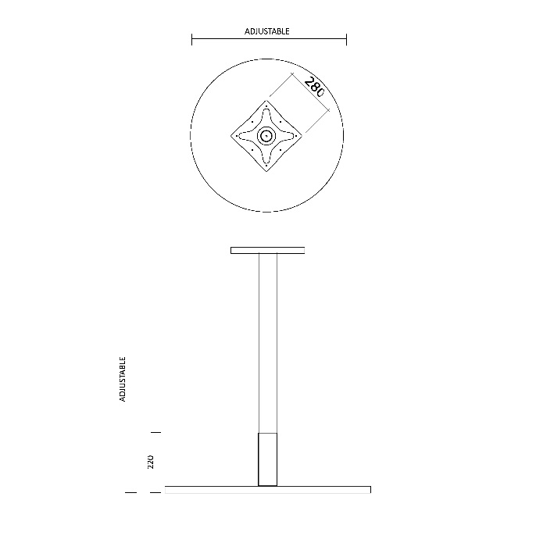Item: Two Tone Table Base Dimensions:

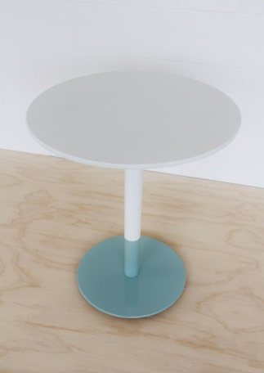

Two tone powdercoat finish available in the sizes as listed

|  |  |  |
| --- | --- | --- |
| **Base Size** | **Suits table top size** | **Height** |
| Disc base 380mm dia | Up to 600mm dia or sq | 695mm H |
| Disc Base 415mm dia | Up to 700mm dia or sq | 695mm H |
| Disc Base 540mm dia | Up to 900mm dia or sq | 695mm H |
| Disc Base 585mm dia | Up to 1000mm dia or sq | 695mm H |

Two Tone Stainless steel and Powdercoat Finish available is sizes as listed

|  |  |  |
| --- | --- | --- |
| **Base Size** | **Suits table top size** | **Height** |
| Disc base 380mm dia | Up to 600mm dia or sq | 695mm H |
| Disc Base 415mm dia | Up to 700mm dia or sq | 695mm H |
| Disc Base 540mm dia | Up to 900mm dia or sq | 695mm H |
| Disc Base 585mm dia | Up to 1000mm dia or sq | 695mm H |

**Standard Powdercoat Colours**

****[](https://www.google.com.au/url?sa=i&rct=j&q=&esrc=s&source=images&cd=&cad=rja&uact=8&ved=&url=https://www.visuallandscapingadelaide.com.au/dulux-powder-coat-colours&psig=AFQjCNFY_XzqQdhjuQMQZbqw1CadKupVCQ&ust=1490914139250018)****

Black Satin or Matt Monument Matt Charcoal Satin Palladium Silver White Satin

Other colours available on request

Lead time: 4 weeks

Warranty: 2 years